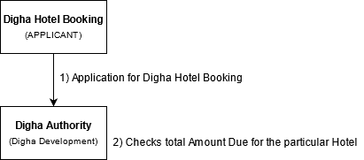

Description:-

At first Digha Hotel Need to be registered to the service plus Portal.

**Step 1:** Then Apply For Digha Hotel Booking Service and would get a receipt of no. of person allotted in hotel.

**Step 2:** Application goes to Digha Development Authority.

Digha Development Authority can check the total no. of visitor visited the hotel and the money due to be paid by particular hotel authority in that month.